

Template for Evidence(s)
UI GreenMetric Questionnaire

University : Andijan State Institute of Foreign Languages
Country : Uzbekistan
Web Address : www.adchti.uz

[1] Setting and Infrastructure (SI)

[1.10] Total area on campus covered in planted vegetation (meter²) (SI.3)

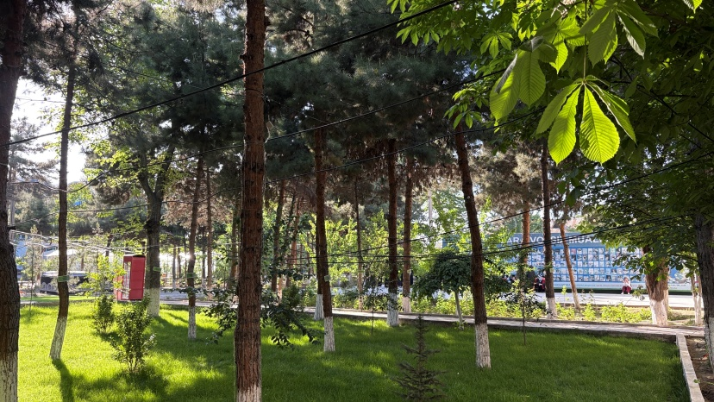 |  | 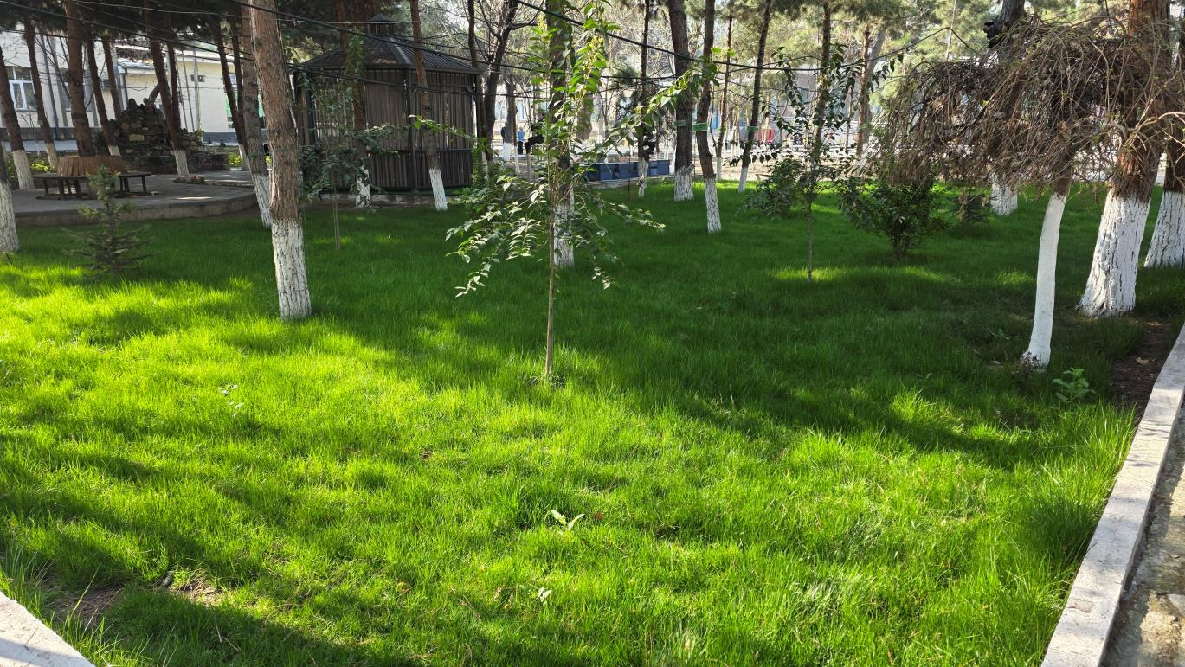
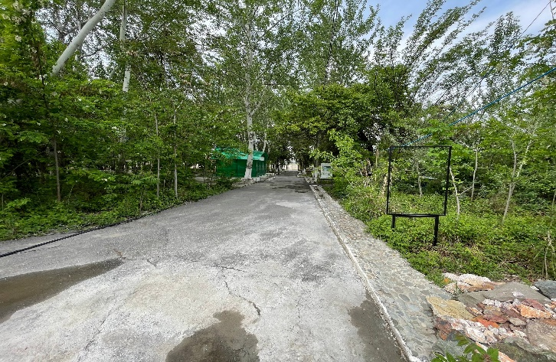
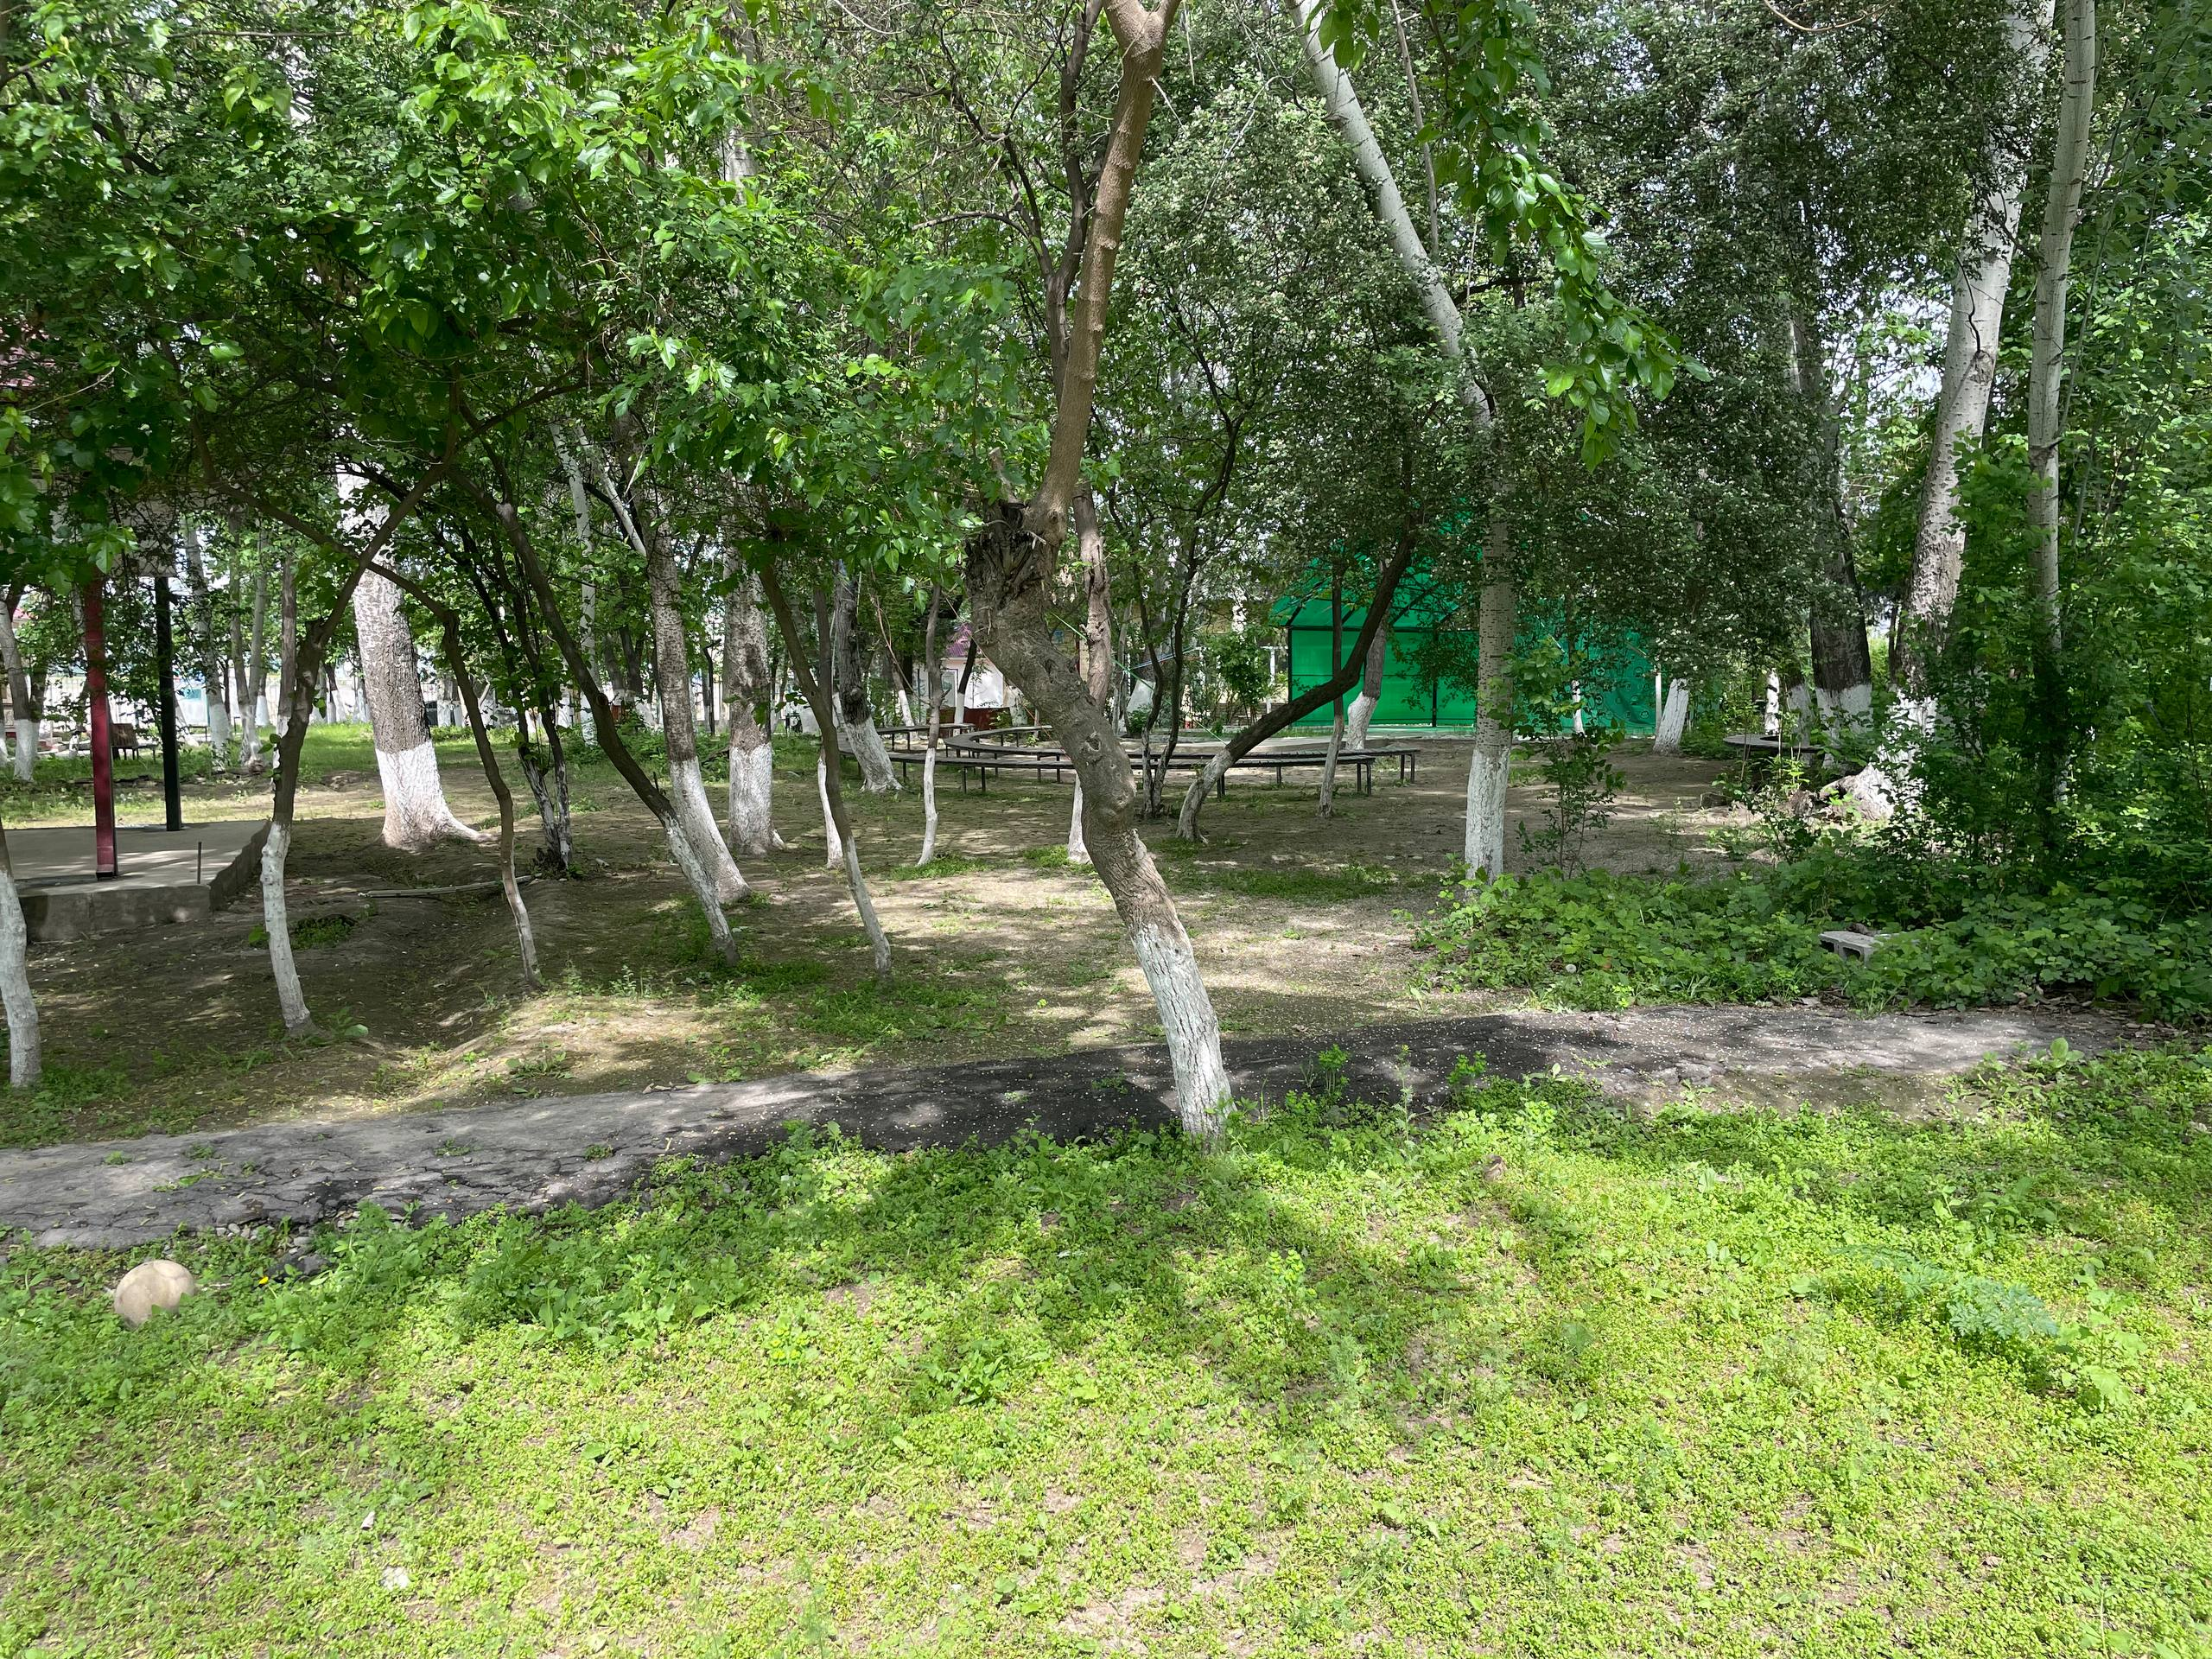
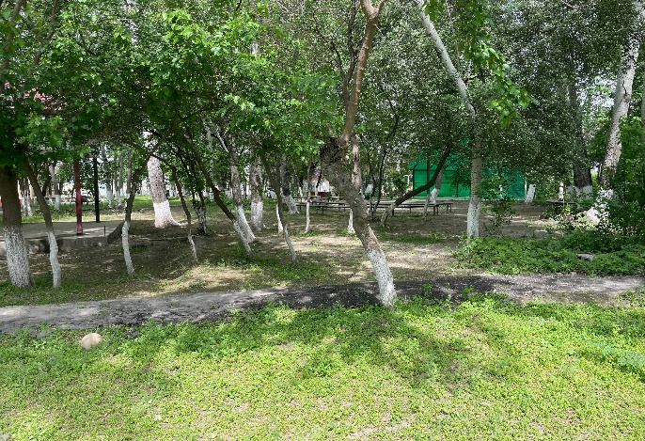 | 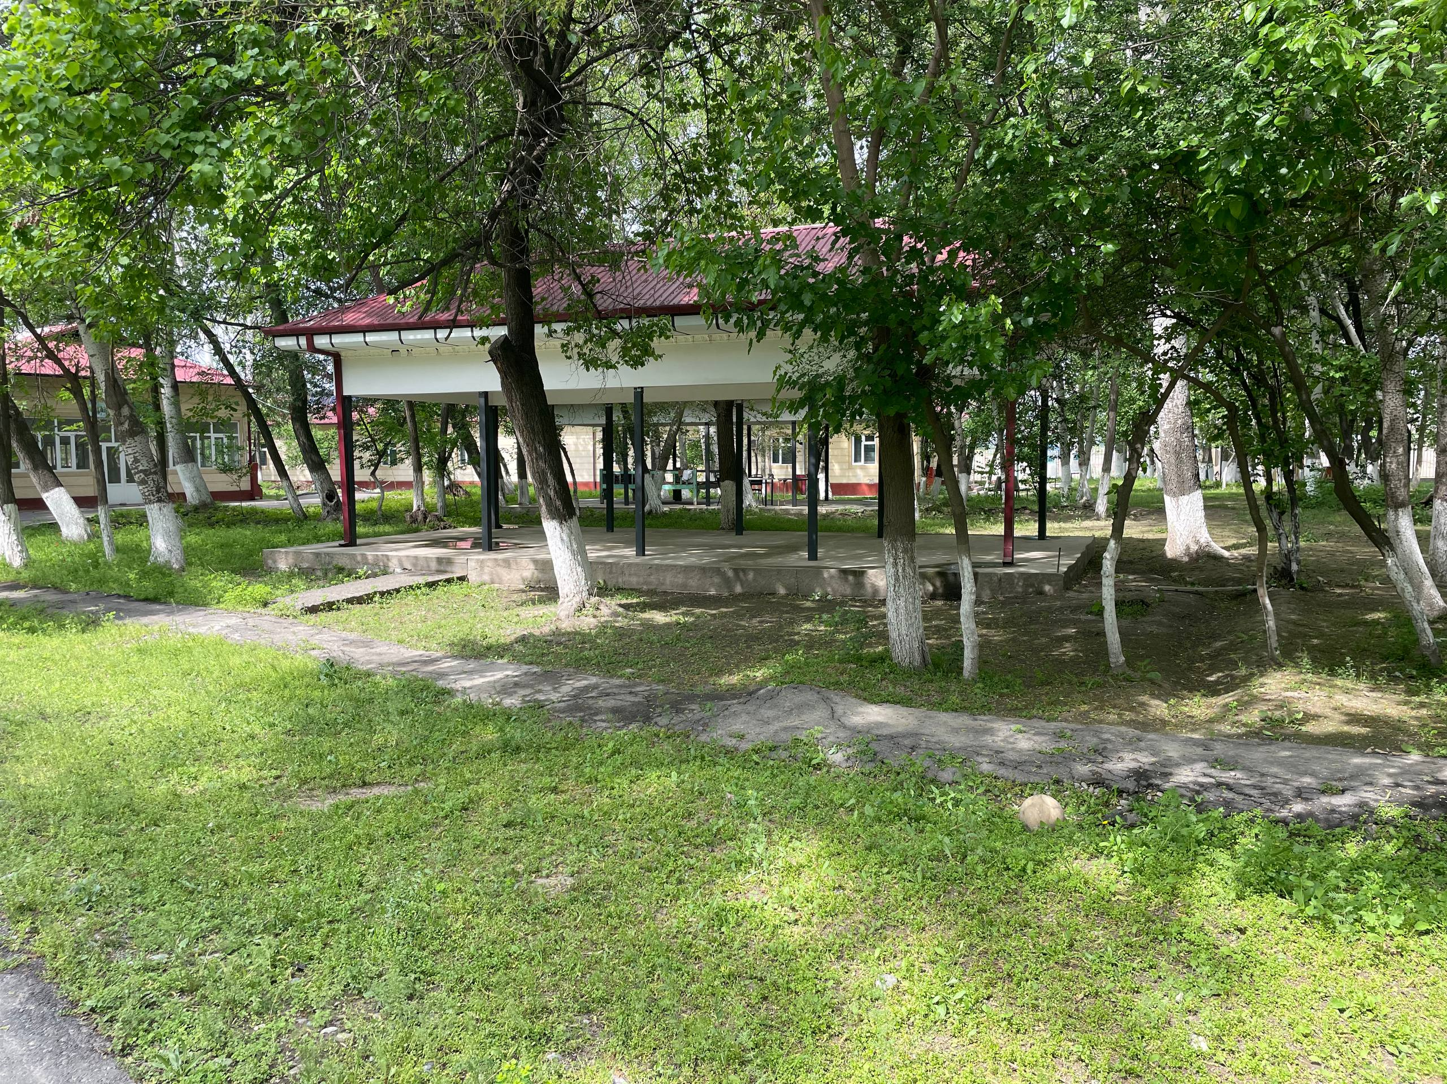
Total Planted Vegetation Area (Andijan State Institute of Foreign Languages,Uzbekistan)

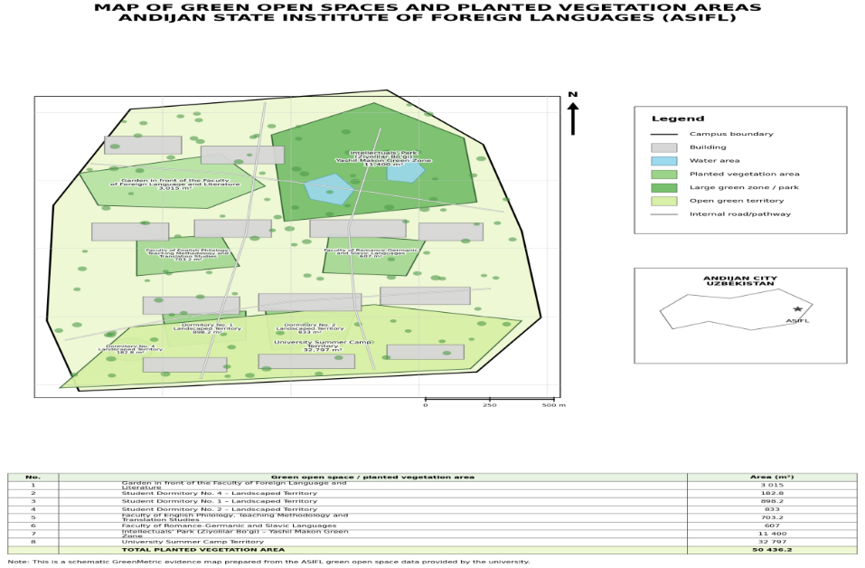

Description:
(Please describe the planted vegetation area in your campus. The following is an example of the description. You can describe more related items if needed.)

Andijon State Institute of Foreign Languages (ADCTI) maintains extensive planted vegetation areas across its campus buildings, student dormitory complexes, and off-campus green zones registered under the institution's ownership. The total planted vegetation area has been measured and verified using satellite imagery and on-site photographic documentation.
The evidence below covers all planted green zones including ornamental gardens, lawns, shrub borders, tree alleys, and natural vegetation areas belonging to the university's main campus, faculty buildings, dormitories, the Intellectuals' Park green space, and the university's summer camp territory.
Summary of Green Areas
No. | Location / Green Area | Area (m²)
1 | Garden in front of the Faculty of Foreign Language and Literature | 3,015 m²
2 | Student Dormitory No. 4 – Landscaped Territory | 182.8 m²
3 | Student Dormitory No. 1 – Landscaped Territory | 898.2 m²
4 | Student Dormitory No. 2 – Landscaped Territory | 833 m²
5 | Faculty of English Philology, Teaching Methodology and Translation Studies | 703.2 m²
6 | Faculty of Romance-Germanic and Slavic Languages | 607 m²
7 | Intellectuals' Park (Ziyolilar Bo'gi) – Yashil Makon Green Zone | 11,400 m²
8 | University Summer Camp Territory | 32,797 m²
 | TOTAL PLANTED VEGETATION AREA | 50,436.2 m²

Additional evidence link (i.e., for videos, more images, or other files that are not included in this file):

