Template for Evidence(s)
UI GreenMetric Questionnaire

University : Andijan State Institute of Foriegn Languages
Country : Uzbekistan
Web Address : www.adchti.uz

[1] Setting and Infrastructure (SI)

[1.9] Total area on campus covered in forest vegetation used for research, teaching, and/or community engagement (meter²) (SI.2)

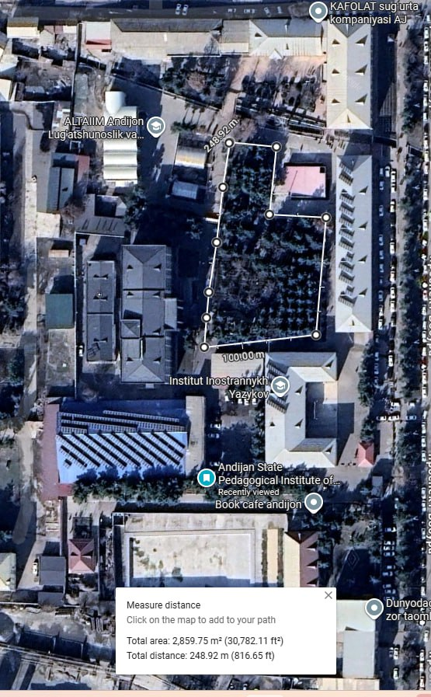
Example of Total Forest Vegetation Area (ASIFL)

Description:
The evidence provided may also include maps showing the location, area size, or distribution of facilities relevant to the indicators

The designated area shown in the map represents a section of green open space located within the campus of Andijan State Pedagogical Institute. Based on geospatial measurement, the total area of the site is approximately 2,859.75 m², with a perimeter distance of 248.92 meters.
This area is primarily covered with dense vegetation, including mature trees and planted greenery, contributing significantly to the campus ecological balance. The presence of tree canopies enhances carbon sequestration, improves air quality, and supports microclimate regulation by providing natural shading and reducing ambient temperatures.
In addition, the green space functions as a water absorption zone, facilitating natural infiltration of rainwater into the soil, thereby reducing surface runoff and supporting sustainable water management practices on campus. The permeable surface and vegetation coverage contribute to minimizing flood risks and enhancing groundwater recharge.
The area also serves multiple purposes for the academic community, including:
- Educational activities, particularly for environmental and biological studies
- Recreational and social use for students and staff
- Biodiversity support, offering habitat for small wildlife and plant species
This green zone reflects the university’s commitment to sustainable campus development, aligning with UI GreenMetric criteria by integrating environmental conservation, functional land use, and support for Sustainable Development Goals (SDGs), particularly SDG 11 (Sustainable Cities and Communities) and SDG 13 (Climate Action).

Total area: 2,859.75 m²
Total distance/circumference: 248.92km

Additional evidence link (i.e., for videos, more images, or other files that are not included in this file):

