

Template for Evidence(s)
UI GreenMetric Questionnaire

University : Andijan State Institute of Foreign Languages
Country : Uzbekistan
Web Address : www.adchti.uz

[1] Setting & Infrastructure

[1.8] The ratio of open space area to total area (SI.1)

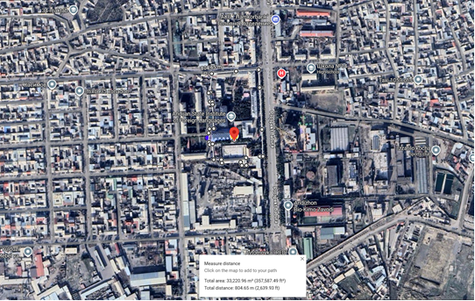

Calculation item | Area / Value
Total campus area | 3 000 000 m2
Total listed building/facility area used for calculation | 58 735.21 m2
Estimated open space area | 2 941 264.79 m2
Ratio of open space to total area | 98.04%
Open space distribution
Open space name | Total area | Duration (in Hours per Weeks)
ASIFL Main Campus Open Space: landscaped green zones, courtyards, internal roads, pedestrian pathways, and open areas between buildings | 2 894 862.79 m2 | 168
The garden affiliated with Andijan State Institute of Foreign Languages | 11 402 m2 | 168
Summer Camp of Andijan State Institute of Foreign Languages open area | 35 000 m2 | 168
Total estimated open space area | 2 941 264.79 m2 | -

Description:
The evidence provided may include maps showing the campus location, total area, boundary size, and the distribution of buildings, open spaces, pedestrian pathways, internal roads, landscaped areas, and other facilities relevant to the indicator.

Andijan State Institute of Foreign Languages (ASIFL) is located in an urban area of Andijan city, Uzbekistan. The total campus area is approximately 3.00 km2, which is equal to 3 000 000 m2. Based on the available campus-building and facility data, the estimated open space area is 2 941 264.79 m2.
Therefore, the ratio of open space area to the total campus area is calculated as follows: (2 941 264.79 m2 / 3 000 000 m2) x 100 = 98.04%, rounded to 98%. The open space includes landscaped green zones, courtyards, internal roadways, pedestrian paths, tree-covered areas, the affiliated garden, and the Summer Camp open area.
Ratio of open space towards total area: 98.04% (approximately 98%)

Additional evidence link (i.e., for videos, more images, or other files that are not included in this file):

