

Template for Evidence(s)
UI GreenMetric Questionnaire

University : Andijan State Institute of Foriegn Languages
Country : Uzbekistan
Web Address : https://adchti.uz

[1] Setting and Infrastructure (SI)

[1.5] Total Campus Area (meter²)

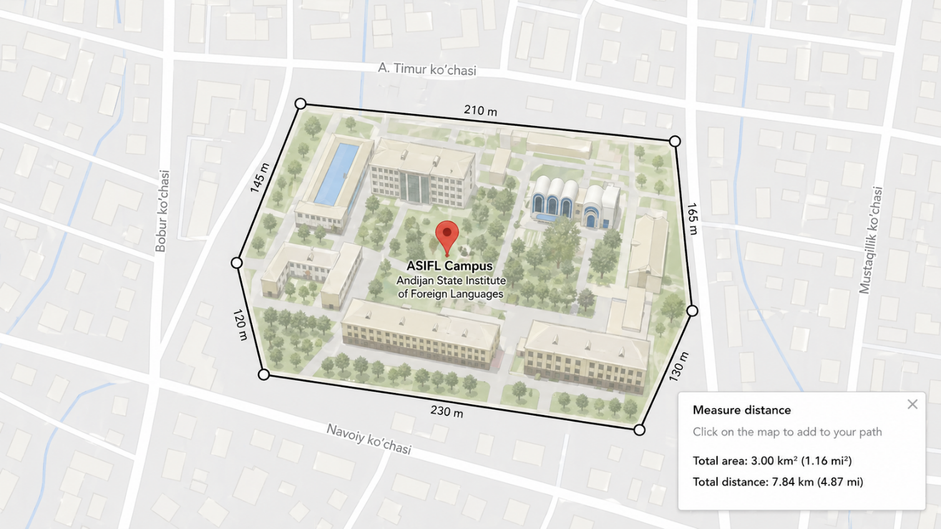
Example of Total Campus Area (Universitas Indonesia, Indonesia)

Description:
Andijan State Institute of Foreign Languages (ASIFL) is located in an urban area of Andijan city, Uzbekistan. The total campus area is approximately 3.00 km², which is equal to 3,000,000 m². The total distance or circumference of the campus area is approximately 7.78 km, which is equal to 7,780 m. The campus consists of several academic and administrative buildings, internal roads, pedestrian pathways, open courtyard areas, and landscaped green zones. Although ASIFL is situated within a densely developed urban environment, the campus includes designated green spaces and vegetation distributed around the buildings and along internal roads. These green areas contribute to the environmental quality of the campus and support the integration of educational infrastructure with sustainable campus development.
The evidence includes a campus map showing the location, total area, boundary distance, and distribution of main facilities within the ASIFL campus area

Additional evidence link (i.e., for videos, more images, or other files that are not included in this file):

