
Template for Evidence(s)
UI GreenMetric Questionnaire

University : Andijan State Institute of Foriegn Languages
Country : Uzbekistan
Web Address : www.adchti.uz

[1] Setting and Infrastructure (SI)

[1.4] Campus Setting

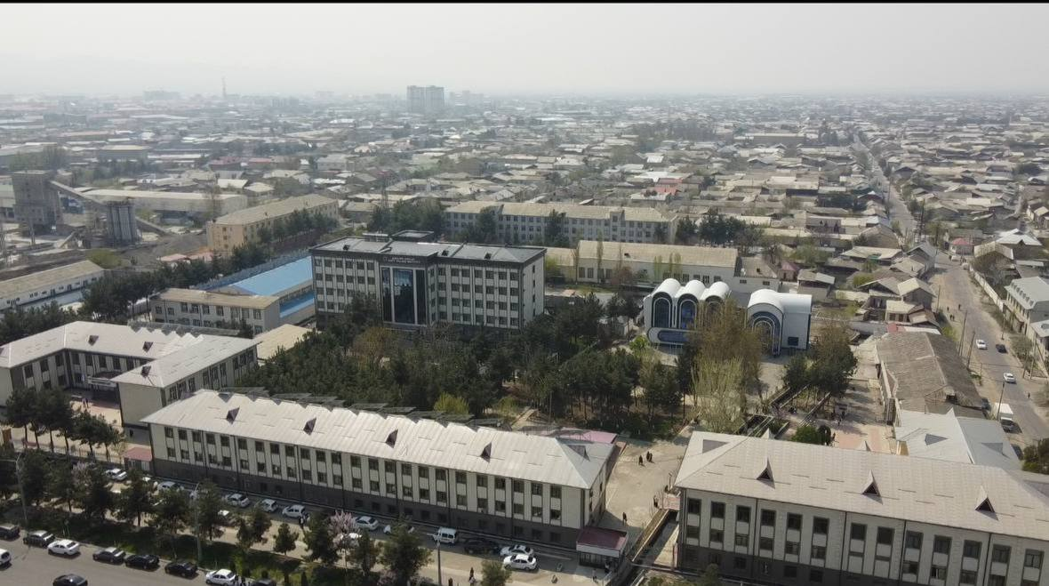
Campus of Andijan State institute of Foreign languages

Description:

Andijan State Institute of Foreign Languages (ASIFL) is located in an urban area with integrated green spaces. ASIFL belongs to Andijan city, which is located in the eastern part of Uzbekistan. The ASIFL campus has a total area of approximately 3.00 km² and consists of several multi-storey academic and administrative buildings.
The campus area includes internal roadways, pedestrian pathways, landscaped green zones, open courtyard spaces, and vegetation distributed between buildings and along internal roads.
Although the surrounding area is characterized by dense urban development, the campus itself contains designated green spaces and environmental elements integrated within the institutional infrastructure.

Additional evidence link (i.e., for videos, more images, or other files that are not included in this file):

