Template for Evidence(s)
UI GreenMetric Questionnaire

University : ……
Country : ……
Web Address : ……

[1] [Setting & Infrastructure]

[1.7] Total campus buildings area

4. Evidence Attachments
The following selected images support the building area and facility distribution information provided above.
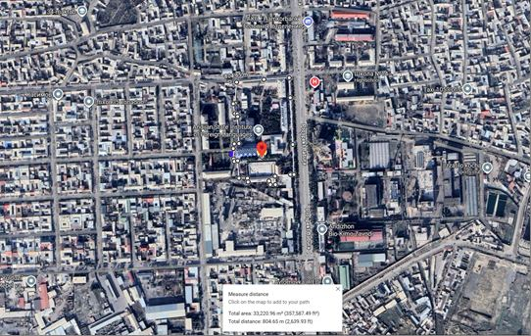
Figure 1. Map view showing the ASIFL campus location and measured campus boundary.
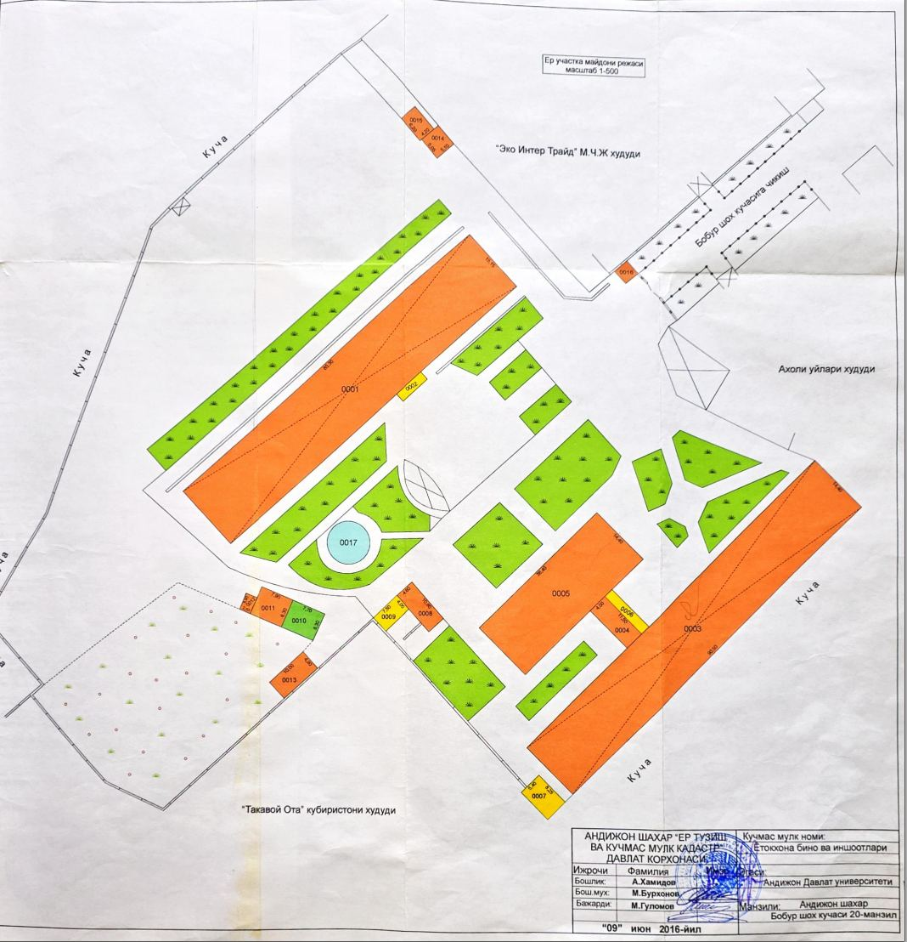
Figure 2. Main campus layout plan showing academic and administrative buildings.
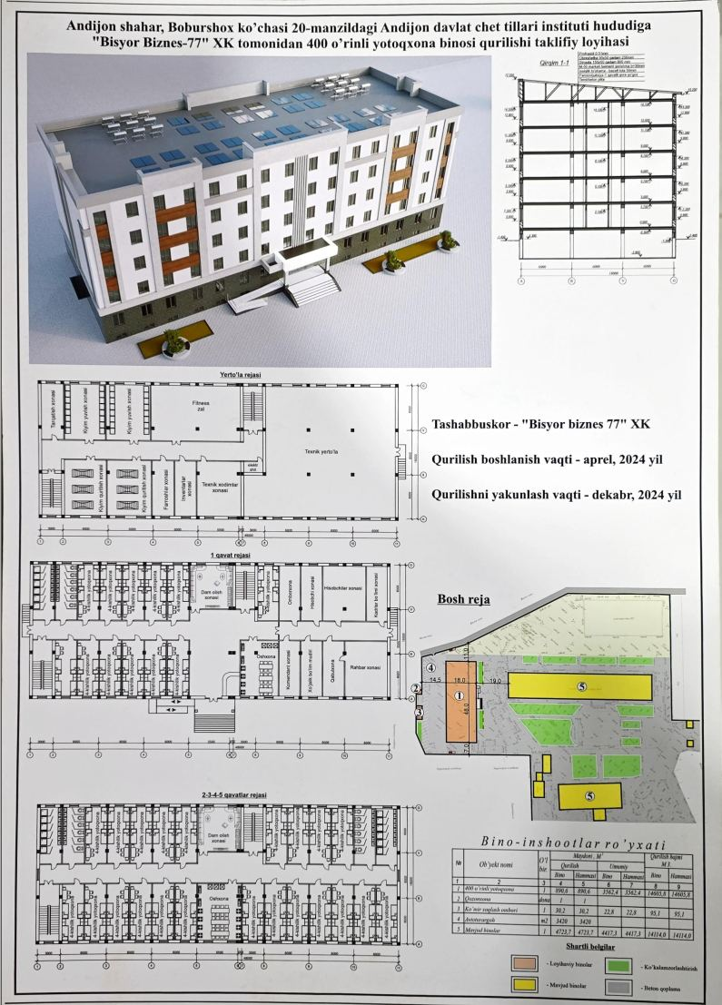
Figure 3. Technical evidence sheet for a main building facility.
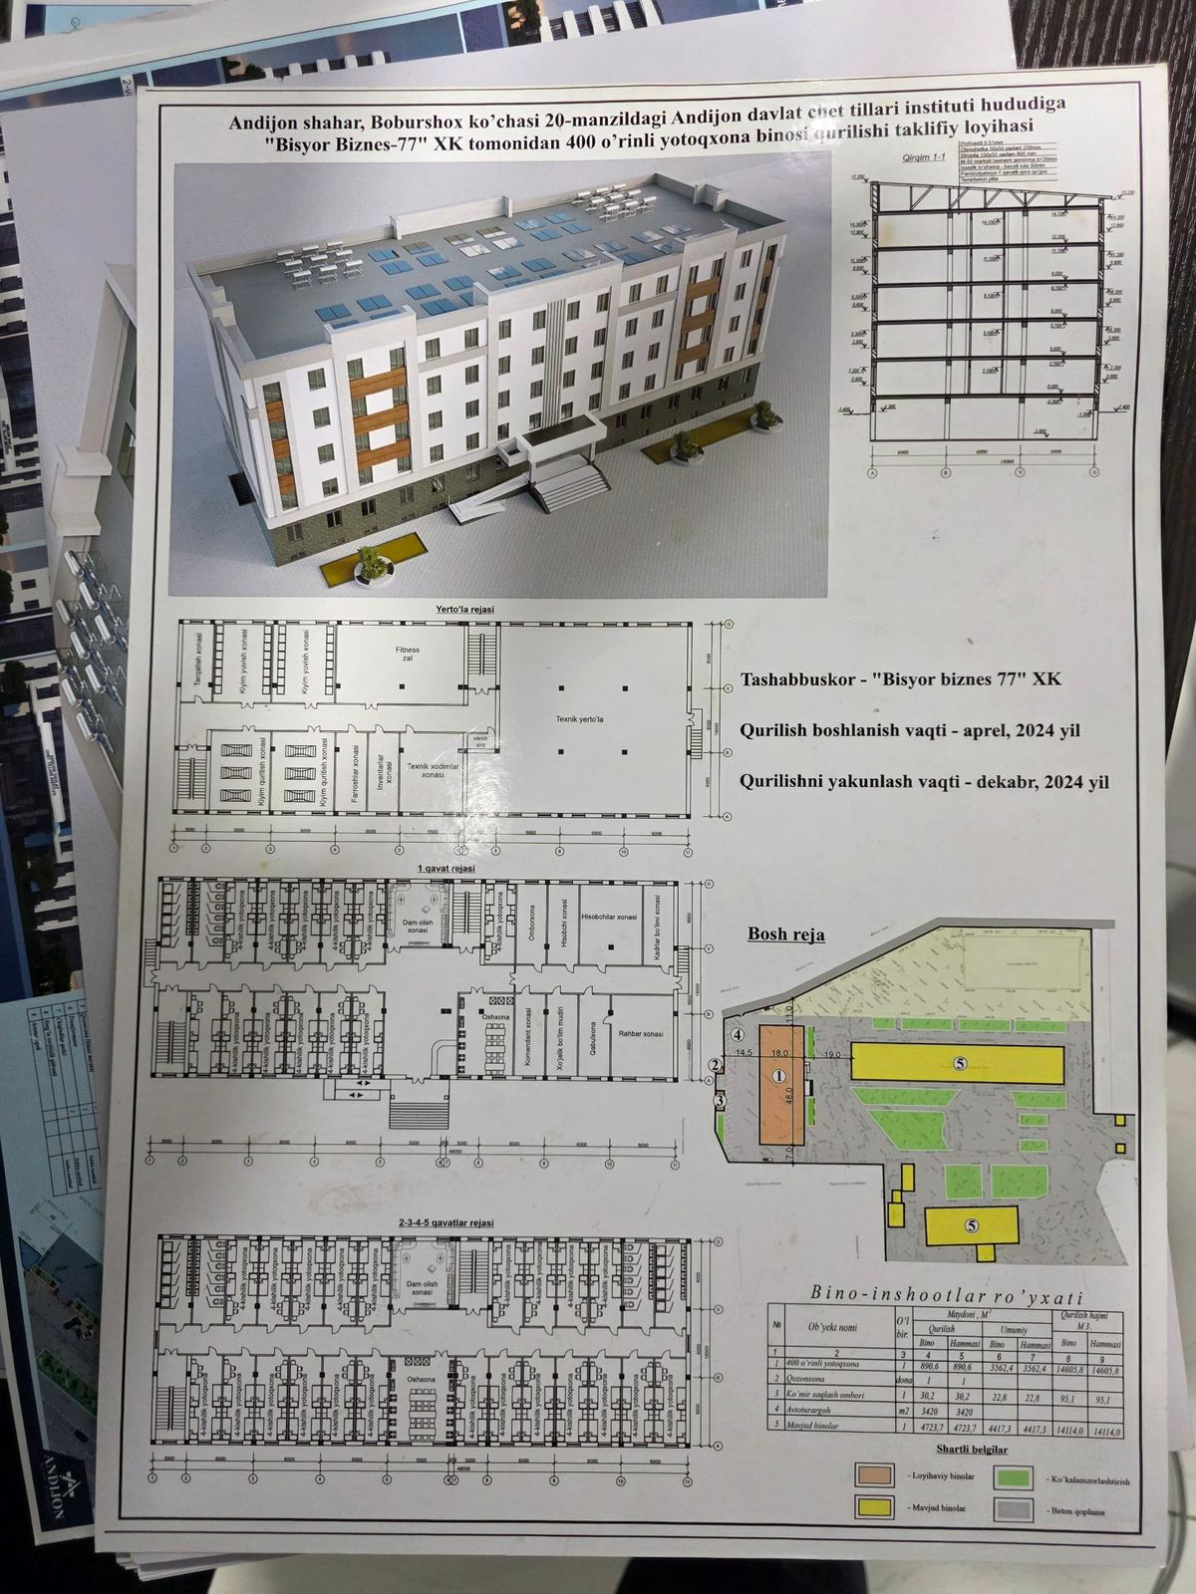
Figure 4. Technical evidence sheet and building plan.
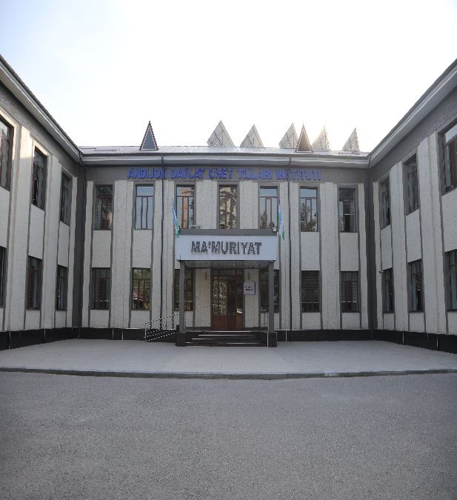
Figure 5. Academic building photograph.
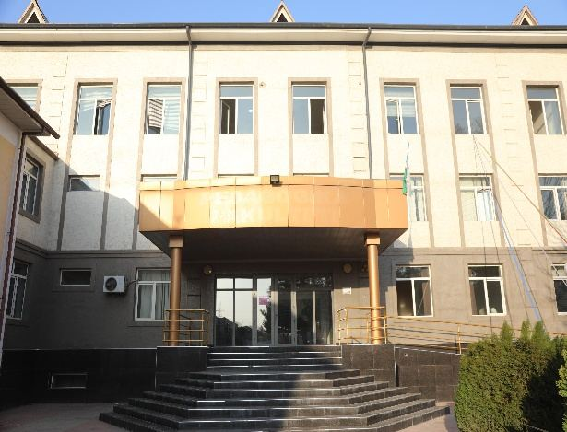
Figure 6. Academic / administrative building photograph.
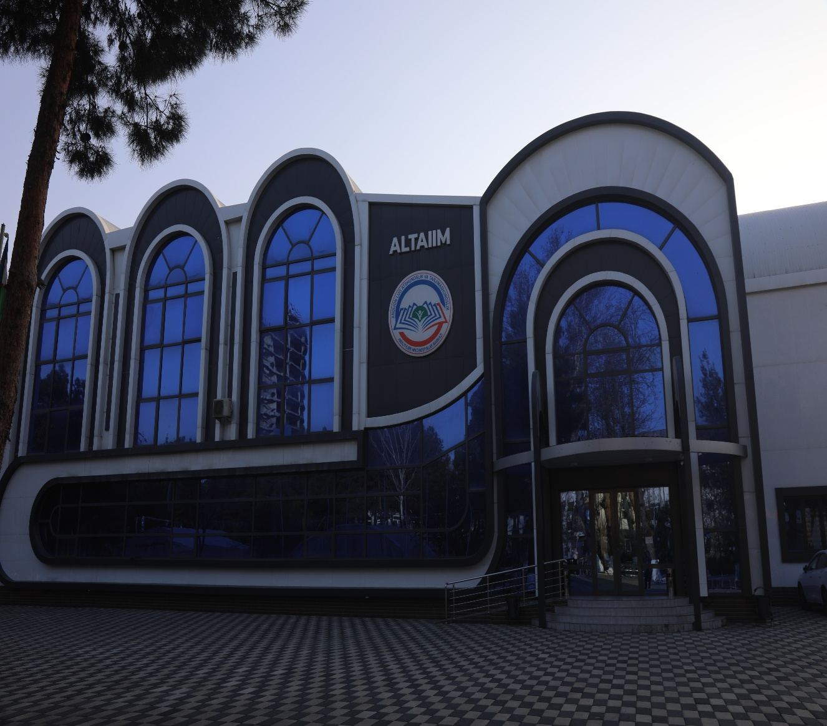
Figure 7. Sports / recreational facility photograph.
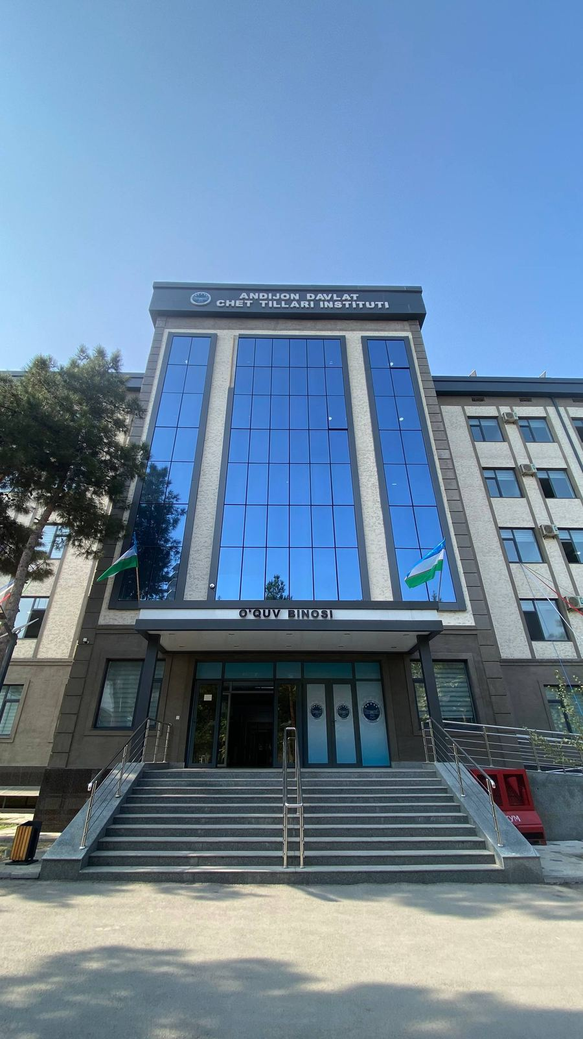
Figure 8. Multi-storey institute building photograph.
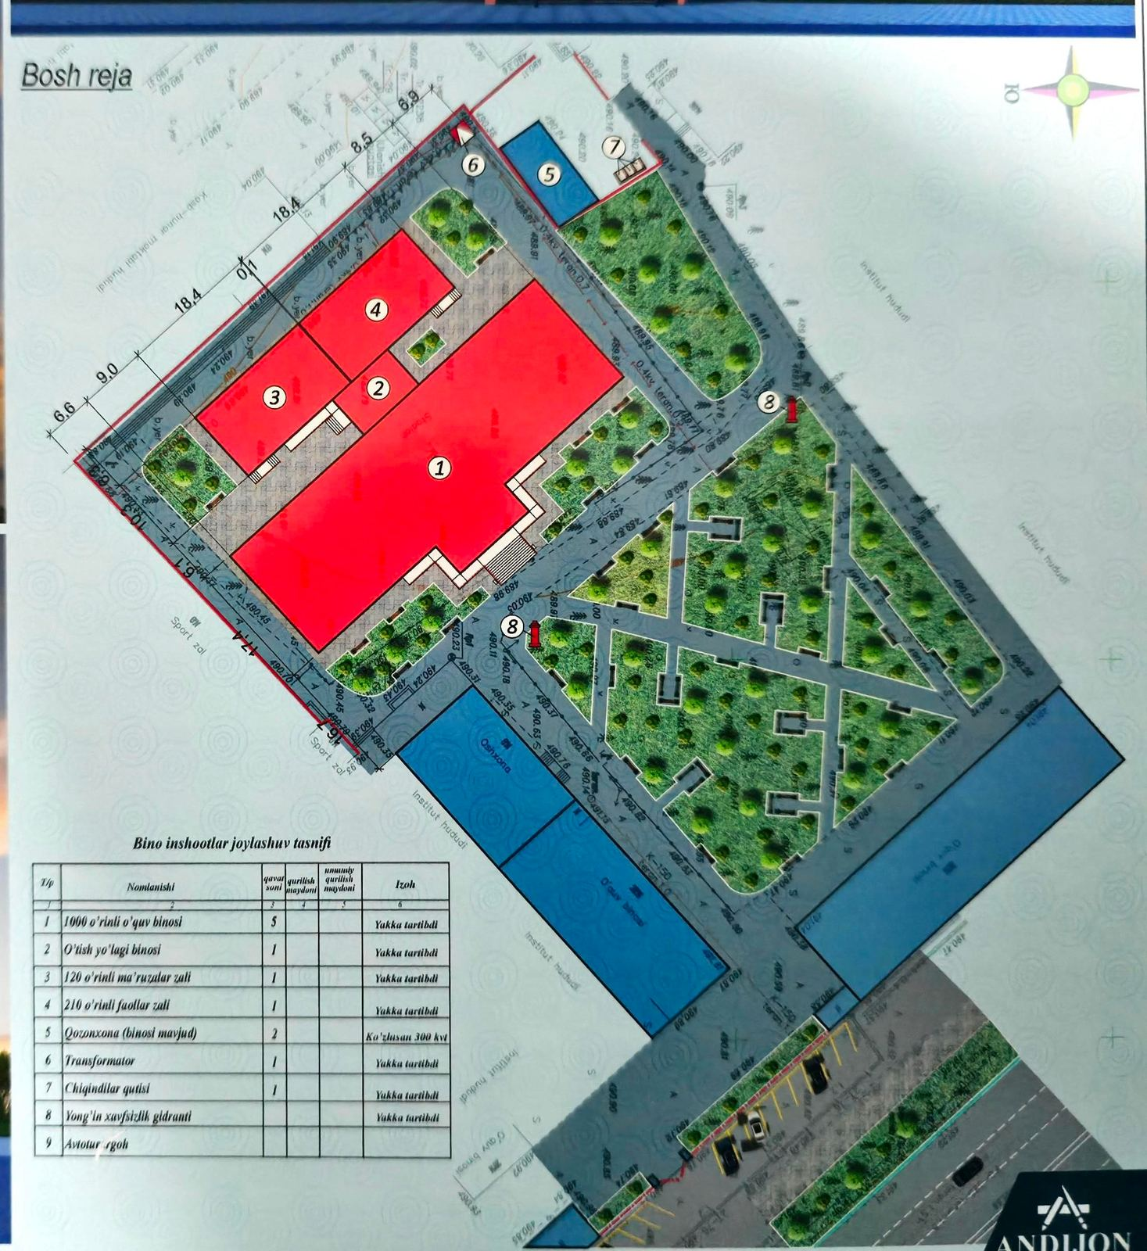
Figure 9. Affiliated land / garden layout evidence.
Verification Statement
Based on the available evidence, the total identified campus buildings/facilities area of Andijan State Institute of Foreign Languages is 24,818.54 m². Supporting land and green areas are reported separately and are not included in this total

Description:

The Andijan State Institute of Foreign Languages (ASIFL) maintains academic, administrative, residential, sport, service and affiliated facilities to support teaching, learning and student life.
The total identified campus buildings/facilities area is 24,818.54 m². This value is calculated from the technical inventory and cadastral data presented in the supporting evidence.
Land-only areas are reported separately in order to avoid double counting. For example, the affiliated garden area and the full Summer Camp territory are shown as supporting land/green areas, while only the building structures of the Summer Camp are included in the building area calculation.
The evidence includes technical layout documents, building plans, photographs and maps showing the location, area size and distribution of main facilities relevant to the indicator.

1. Calculation Summary
No. | Building / facility group | Area (m²)
1 | Main campus academic, administrative and auxiliary buildings (Buildings A/B) | 9,579.11
2 | Building C / Faculty of Romano-Germanic and Slavic Languages | 5,854.41
3 | Student Dormitory 1 & 2 complex | 4,495.57
4 | Student Dormitory 3 | 3,562.40
5 | ALTAIIM building | 566.05
6 | Summer Camp building structures | 761.00
 | Total identified campus buildings/facilities area | 24,818.54

Note: The calculation includes buildings and facility structures. Land-only areas are listed in a separate table below and are not added to the total campus buildings area.
2. Additional Land / Green Areas Reported Separately
No. | Land / green area | Area (m²)
1 | Affiliated garden of ASIFL | 11,402.00
2 | Total Summer Camp territory | 35,000.00

3. Detailed Building Area Data
3.1 Main Campus Academic, Administrative and Auxiliary Buildings
Code | Name of building / structure | Floors | Area (m²)
.0001 (A-A1-A3) | Educational building | 3 | 910.00
.0002 (A3) | Guardhouse | 1 | 14.95
.0003 (B-B1) | Educational building | 2 | 1,221.56
.0004 (B3) | Educational building | 1 | 283.79
.0006 | Guardhouse | 1 | 38.64
.0070 (B) | Hall | 1 | 423.36
0008 (B) | Hall | 1 | 140.14
0009 (B2) | Hall | 1 | 166.32
0010 (B#) | Shelter | 1 | 63.70
0011 | Toilet | 1 | 86.85
.0012 | Kitchen / dining building | 1 | 248.97
.0013 | Shelter | 1 | 8.96
.0019 (Ж) | Toilet | 1 | 21.00
.0020 (Z) | Toilet | 1 | 67.50
0021 (K) | Toilet | 1 | 55.25
0022 (L) | balcony | 1 | 36.00
.0023 (M) | Bomb shelter | 1 | 211.68
.0024(H-H1), .0026(H2), .0025(H3-H4) | Sports hall | 2 | 2,271.16
.0027(P) | Administration | 2 | 861.80
.0029(C) | Training hall | 1 | 856.88
.0032(P-P1) | Library | 2 | 340.60
.0033 | Swimming pool | 1 | 1,250.00
Subtotal: 9,579.11 m²
3.2 Other Main Buildings and Affiliated Structures
No. | Facility / description | Area (m²)
1 | Building C / Faculty of Romano-Germanic and Slavic Languages. Academic building; construction footprint: 1,617.13 m²; student capacity: 1,000. | 5,854.41
2 | Student Dormitory 3. Residential building; construction footprint: 890.60 m². | 3,562.40
3 | ALTAIIM building. Academic / training facility. | 566.05
4 | Summer Camp building structures. Affiliated recreational facility; total Summer Camp territory: 35,000 m². | 761.00

3.3 Student Dormitory 1 & 2 Complex
Code | Building / structure | Floors | Area (m²)
0001 | Dormitory building | 4 | 1,292.30
0002 | Glass porch | 1 | 10.65
0003 | Dormitory building | 4 | 1,303.20
0003 | Cellar / basement | 0 | 1,236.72
0004 | Transition building | 1 | 46.00
0005 | Kitchen building | 1 | 524.16
0016 | Guardhouse | 1 | 11.70
0017 | Swimming pool | - | 70.84
Subtotal: 4,495.57 m²

