Template for Evidence(s)
UI GreenMetric Questionnaire

University : Andijan state Institute of foreighn languages
Country : Uzbekistan
Web Address : www.adchti.uz

[1] Setting and Infrastructure (SI)

[1.22] Conservation: plant, animal, and wildlife, genetic resources for food and agriculture secured in either medium or long-term conservation facilities (SI.10)

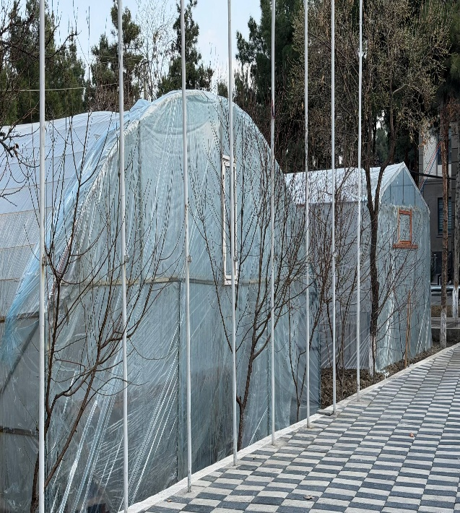 | 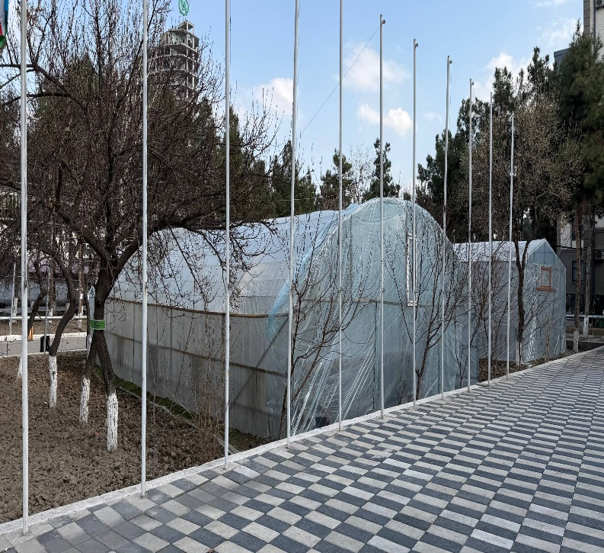
Green House (ASFIL )
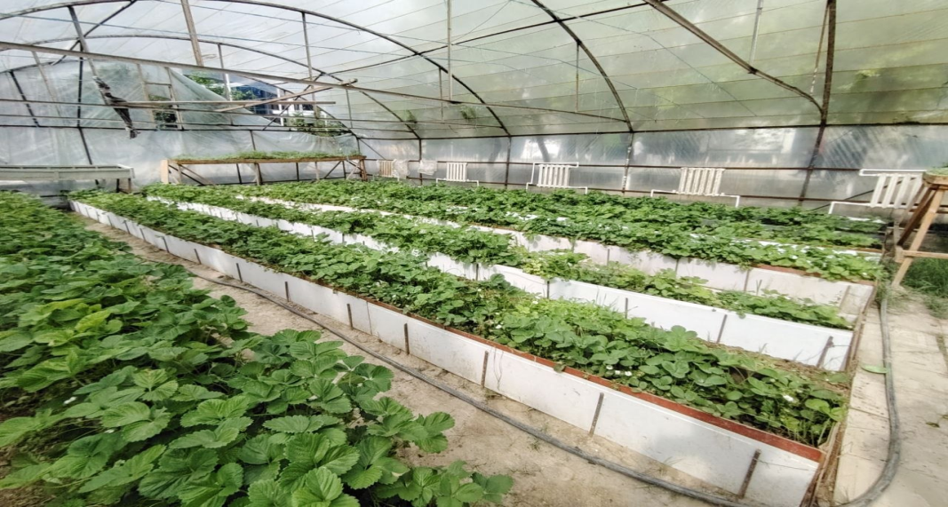
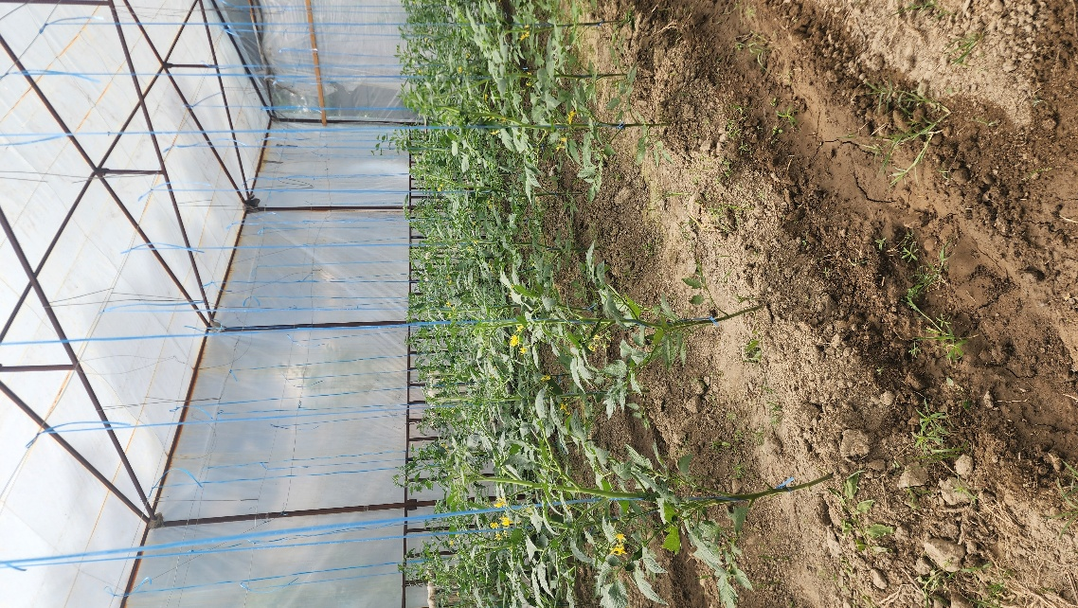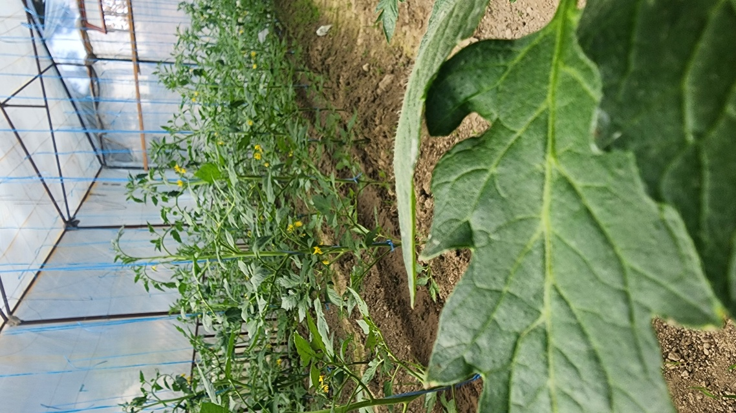
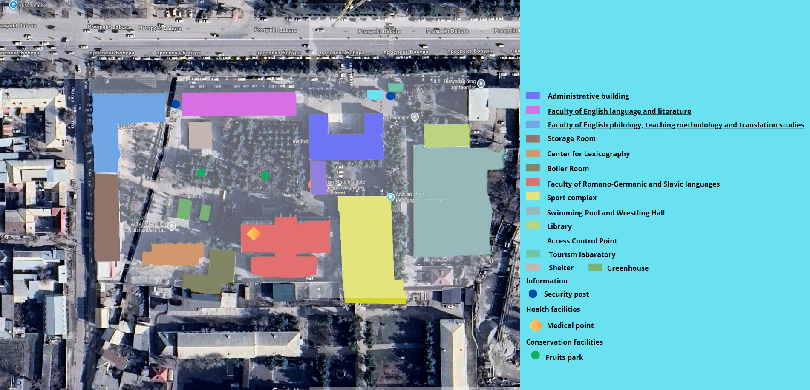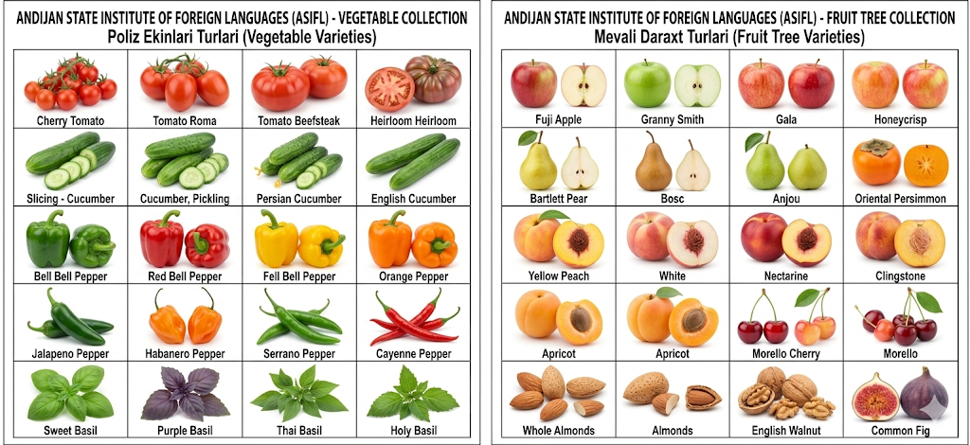
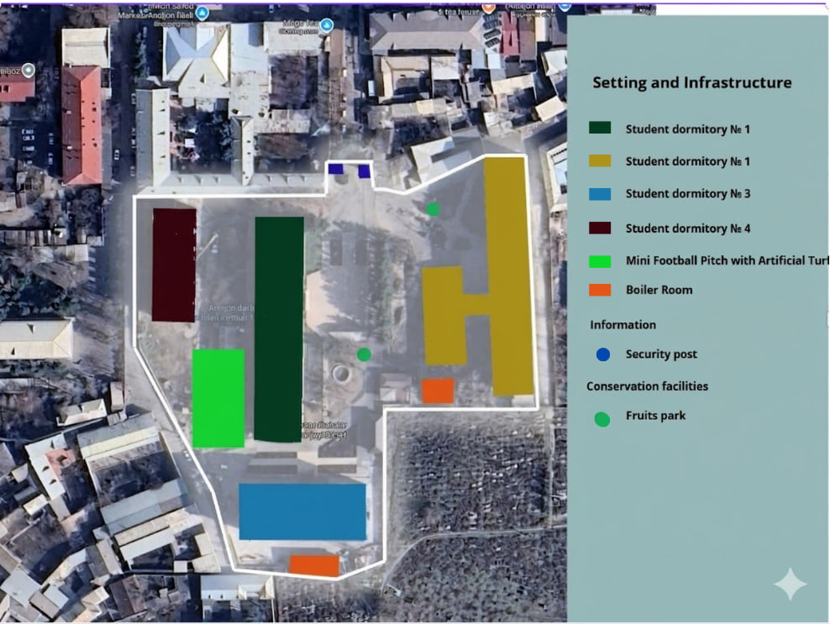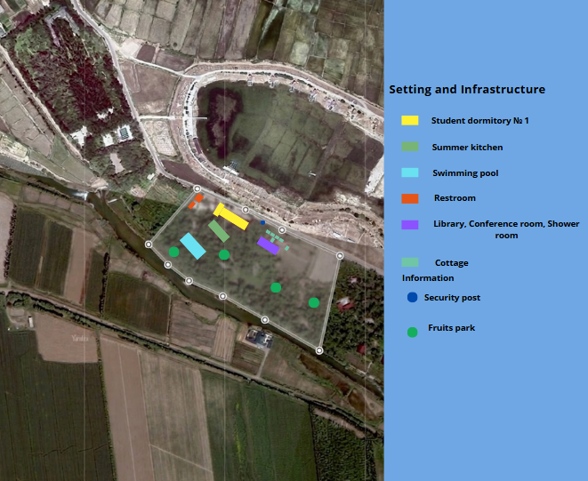

Description:
The campus is systematically organized with clearly defined zones for academic, residential, recreational, and service functions. Key infrastructure includes administrative and academic buildings, student dormitories, libraries, sports complexes, and essential support facilities such as boiler rooms, storage areas, and security posts. The presence of access control points and safety infrastructure ensures a secure and well-managed campus environment, contributing to sustainable and inclusive institutional operations.
A significant component of the campus design is the integration of green and conservation areas. The campus includes fruit parks, landscaped open spaces, and designated agricultural zones that enhance biodiversity and ecological balance. These green areas serve multiple purposes, including environmental protection, aesthetic improvement, and educational use, supporting long-term sustainability objectives.
The university actively promotes sustainable agriculture through the establishment of greenhouse facilities and open-field cultivation areas. These facilities support the production of diverse crops, including vegetables (tomatoes, cucumbers, peppers, herbs) and fruits (apples, pears, peaches, cherries, and others). The use of controlled environments, structured planting systems, and efficient irrigation practices ensures
optimal resource utilization, reduces environmental impact, and enables year-round agricultural productivity.
In addition, the documented diversity of plant species reflects the institution’s commitment to conserving genetic resources and promoting food sustainability. These agricultural and green infrastructure elements function as living laboratories, providing students with practical learning opportunities and supporting research in environmental sustainability, agriculture, and resource management.
Overall, the campus demonstrates a holistic and sustainable model of development that aligns with multiple SDGs, including:
- SDG 2 (Zero Hunger): through sustainable food production and agricultural education
- SDG 3 (Good Health and Well-being): by providing a safe, healthy, and green campus environment
- SDG 4 (Quality Education): via experiential learning and research opportunities
- SDG 11 (Sustainable Cities and Communities): through efficient land use and integrated infrastructure
- SDG 12 (Responsible Consumption and Production): by implementing resource-efficient agricultural practices
- SDG 13 (Climate Action): through environmentally responsible campus planning
- SDG 15 (Life on Land): by preserving biodiversity and green spaces

Additional evidence link (i.e., for videos, more images, or other files that are not included in this file):

