
Template for Evidence(s)
UI GreenMetric Questionnaire

University : Andijan State university of foreign languages
Country : Uzbekistan
Web Address : www.adchti.uz

[1] Setting and Infrastructure (SI)

[1.21] Health infrastructure facilities for students, academics and administrative staffs' wellbeing (SI.9)

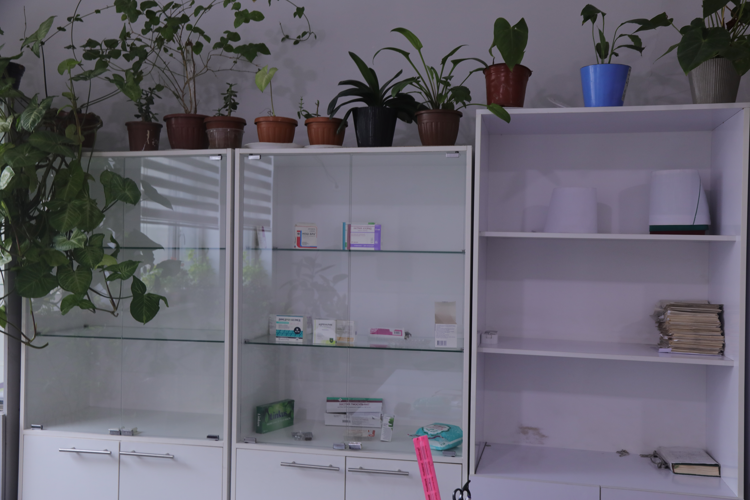

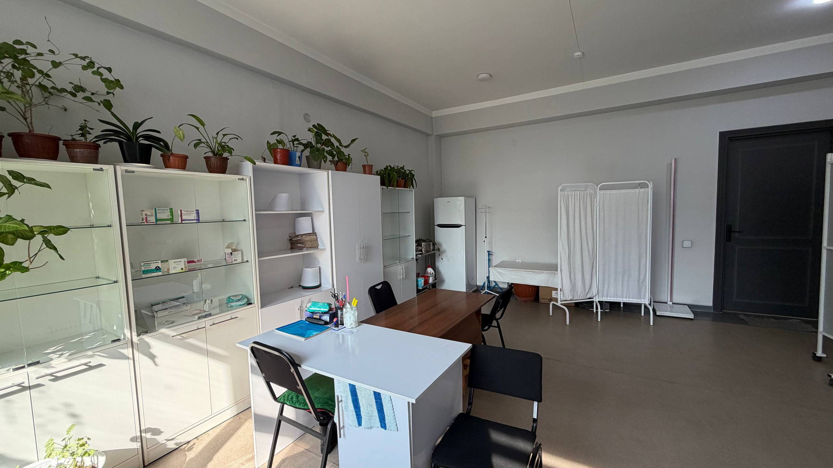

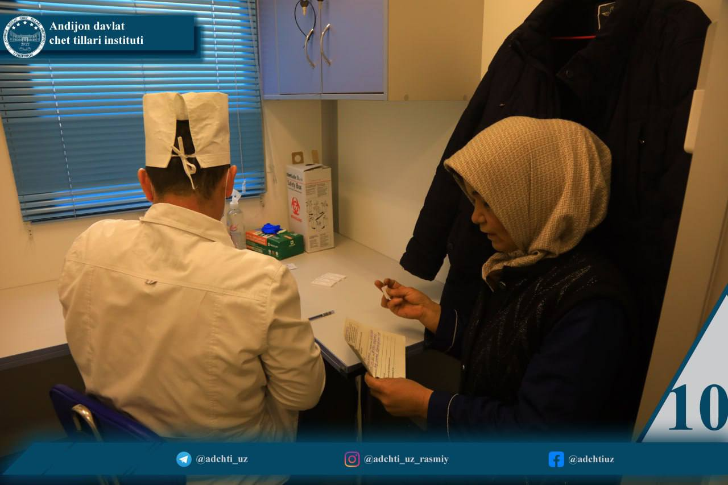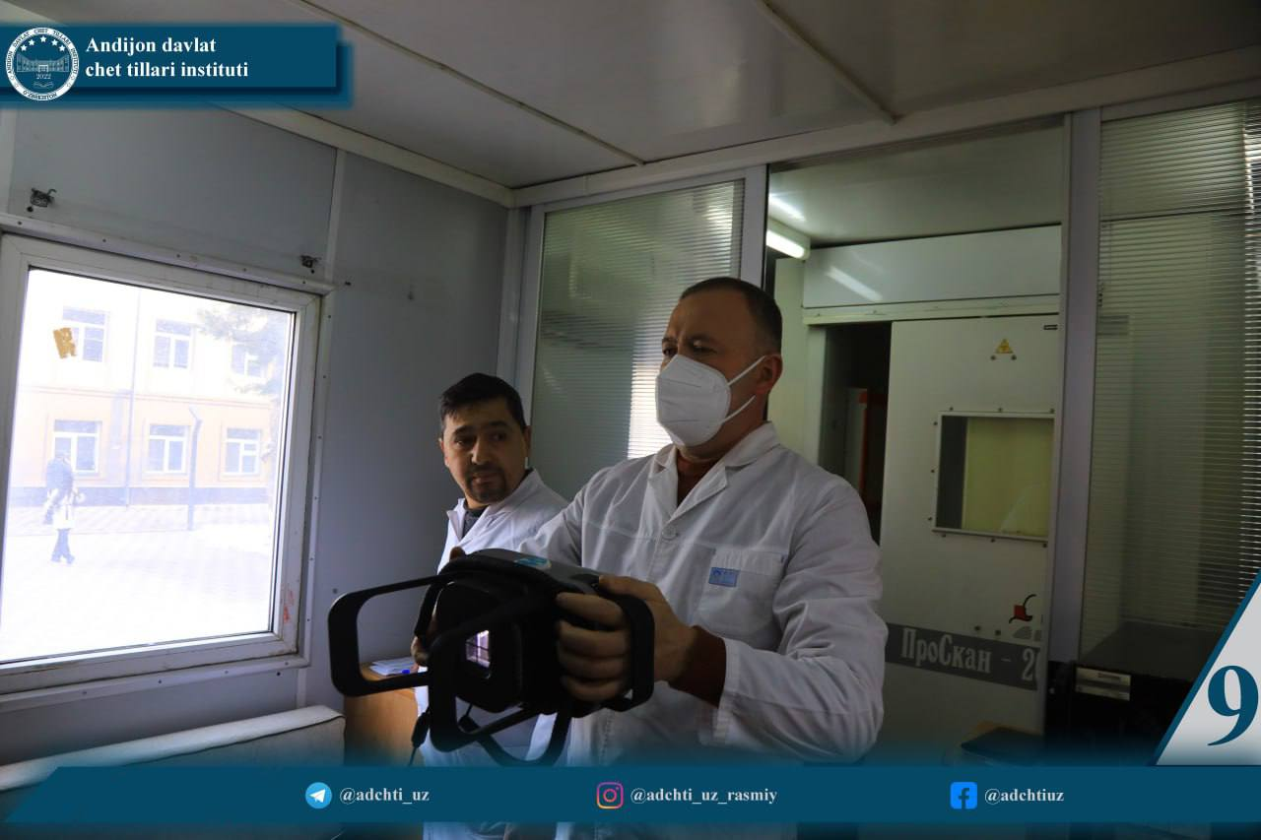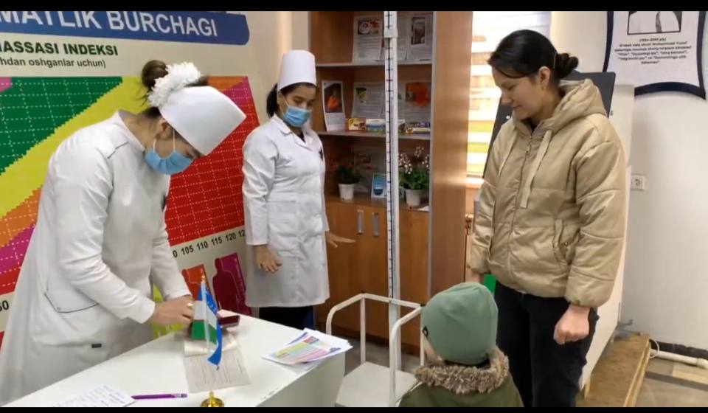
- Satellite Clinic

Description:

The evidence provided may also include maps showing the location, area size, or distribution of facilities relevant to the indicators

Andijan State Institute of Foreign Languages (ASIFL), in cooperation with the Andijan Regional Health Department, each month organizes large-scale health initiatives aimed at promoting the wellbeing of students, academic staff, and administrative personnel. One such initiative, conducted under the framework of the “Health Marathon”, reflects the institute’s commitment to fostering a healthy campus environment.
Held under the motto “Health Begins with Medical Culture”, this comprehensive medical campaign involved university leadership, faculty members, employees, and students. During the event, highly qualified medical specialists from across the region carried out in-depth medical examinations covering various health areas. Particular emphasis was placed on early detection of diseases, preventive care, and raising awareness of healthy lifestyles.
In addition to periodic health campaigns, ASIFL maintains a Campus Medical Room that provides continuous access to primary healthcare services. The facility is equipped to deliver:
- Basic medical consultations
- First aid and emergency response
- Preventive healthcare services and health monitoring
The Campus Medical Room operates during working hours and is accessible to all members of the institute community.
Through the integration of regular medical campaigns and permanent healthcare facilities, ASIFL ensures a proactive approach to health management, contributing to a safer, healthier, and more sustainable campus environment.

Additional evidence link (i.e., for videos, more images, or other files that are not included in this file):

